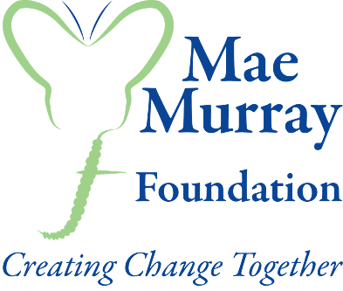

Full Membership
(complete as an individual or on behalf of a family)

Membership of the Mae Murray Foundation is awarded to an individual who shares the Mae Murray Foundation vision, subscribes to its objects and who may benefit directly, or have a family member who will benefit, from its activities. Every member will be invited to attend our Annual General Meeting (AGM) and is entitled to a single vote.

Any family wishing to join Mae Murray Foundation should nominate just one lead named family representative who commits to the membership obligations for the whole family.

This named family member MUST:
- be the lead name on this membership form
- be the email contact for the entire family
- book events on behalf of the family
- hold the membership card for the entire family and be responsible for its use
- take the responsibility for ensuring that anyone using any Mae Murray Foundation equipment under any of the charities loan schemes adheres to the Terms and Conditions of use of each piece of equipment
- ensure that Membership Card is kept safe at all times and not shared with others

Lead Name: __________________________________

Address: __________________________________

Postcode: __________________________________

Telephone: __________________________________

Mobile: __________________________________

Email Address: __________________________________

Please complete the following information:

List: All Family Members | Date of Birth | Access Requirements/ Medical condition if applicable  Eg. vision impairment, wheelchair user, learning difficulty

How information about you will be used:

We will not share your information with any third party. We would like to correspond with you about membership benefits, events, project design and how we can improve the service we provide to you and/or your family. We may also send information from other organisations that may be of benefit to you and your family. We will correspond with you in a variety of ways such as by: post, telephone, email and SMS.

Please tick the appropriate box for your preference and sign below:

( ) I want to be placed on the mailing list to hear about member information as listed above.

( ) I do not want to receive membership information as listed above. I am ONLY joining to avail of equipment loan schemes.

Signed: ________________________________

PRINT NAME: ________________________________

DATE: __________________________________________

To view our Privacy Policy, please go to our website: www.maemurrayfoundation.org
If you have any further information, please contact us using the details below.

Please return completed form to Mae Murray Foundation:
Email: info@maemurrayfoundation.org
Post: Mae Murray Foundation, A9B Innovation Suite, Ash Building, Willowbank Business Park, Millbrook, Larne, Co. Antrim, BT40 2SF

For office use only

Date Application Received: _____________

Membership granted and countersigned:

Manager

PRINT NAME ____________________________________________

SIGNED ________________________________________________

DATE _________________________

Director / Countersign

PRINT NAME ____________________________________________

SIGNED ________________________________________________

DATE _________________________

Membership Notification Pack issued ( ) Date ________

Membership Number : _______________________________________

Registered Charity No. NIC100842

